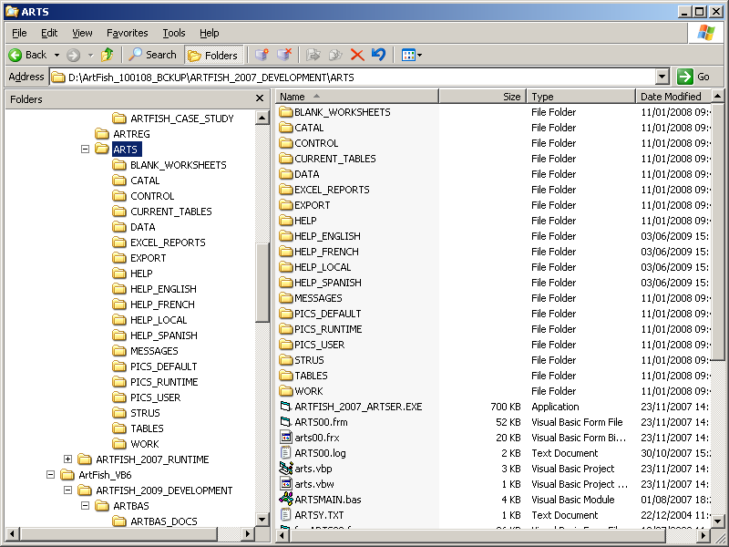

ArtSer 2007 Subdirectory structure

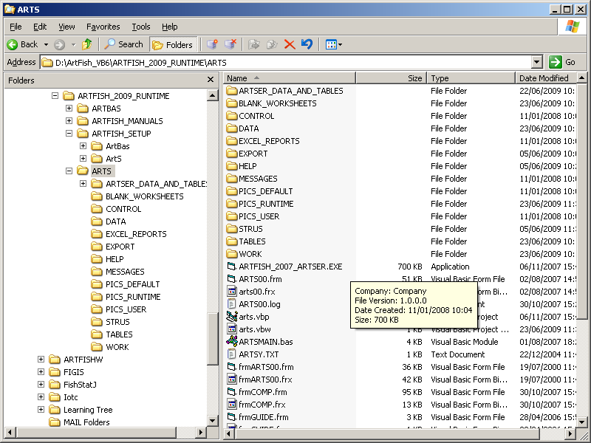

ArtSer 2009 Subdirectory structure

